MoodleDirect

Courses for external (non-banner) users

User Guide for Staff

Each document should also be listed on our “Help Materials Log”, which can be found here - U:\ILS\LIS_Shared\Web Services\Help Materials.

VERSION | DATE | DETAILS | AUTHOR | AUTHORISED BY
M0.1 | 23/04/2015 | Creation of document | Mike Hatherly
M0.2 | 11/05/17 | Updated link for course request | Mike Hatherly

Contents
Overview 3
Request a new external course shell 4
Log into MoodleDirect 4
Setting enrolment key and populating course content 4
Setting the enrolment key for your course 4
Populating course content 5
Providing external users with instructions on registration and enrolment 5
How do users access my course? 5
Where do I locate the direct link to my course? 6

Overview
This document describes the process for administering a non-banner course on the Moodle site for non-UoG users (previously known as Acceptors/External moodle). This site is called MoodleDirect. This can be used for Continual Professional Development (CPD) or Short Courses.

MoodleDirect has been configured to allow users to self-register using an email address, then self-enrol to courses.

The process, described in more details in the following sections, is as follows
Request a new external course shell

Empty Course shell setup at https://moodledirect.gre.ac.uk

Setting enrolment key and populating course content

Provide external users with instructions on registration and enrolment
Create MoodleDirect account
Web Services
Course Leader
External User

Enrol on course

Request a new external course shell
Before a course can be populated with content you will need to request that a new shell be created.
Please use the Non-Banner course request form mentioning in the Notes/Further comments that the course is to be created for External users
http://www.gre.ac.uk/it-and-library/forms/non-banner-course-request

Log into MoodleDirect
- Open your browser and navigate to https://moodledirect.gre.ac.uk
- You will be presented with the authentication page as shown below.
Choose ‘Login via the University of Greenwich Portal’
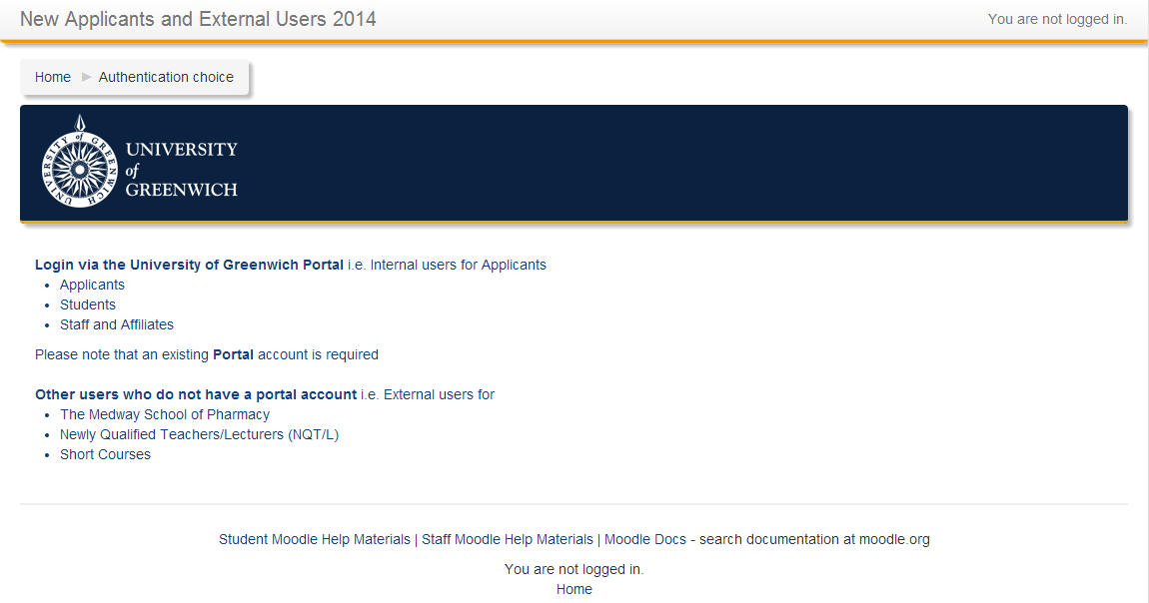
Select ‘Login via the University of Greenwich Portal’.
- You will be re-directed to the portal login page; enter your details to log in.
- When logged in successfully you will be redirected back to MoodleDirect

Setting enrolment key and populating course content
Once your new Moodle shell has been created, you will be notified by Web Services that your course is ready.
If you specified an enrolment key (password) when requesting the course this will already be configured.

Setting the enrolment key for your course
In order to ensure that your course is not openly available to all external users who have created an account on External Moodle, you are able to set an enrolment key (password).
When an external user clicks the title of your course they will be shown a Course Summary (from the course settings) and will be asked to enter the enrolment key in order to enrol in the course and access the content.

To set/change the enrolment key
Select Course
- Administration block -> Users -> Enrolment Methods
- Click the ‘edit settings’ icon (cog) to the left of Self Enrolment
- To view the enrolment key if it is already populated; tick the box marked ‘Unmask’ to the right of the Enrolment Key field.
- To change the enrolment key type the new value in the Enrolment Key field
- Click the Save changes button at the bottom of the screen

Populating course content
You can now start adding content to your course in readiness for external users. If you have not already completed the Moodle for Beginners online course, this is a useful guide to creating basic content.
The course can be found on our Student Moodle site and is available to all staff (no enrolment key is required)
http://moodle.gre.ac.uk/course/view.php?id=29398
Don’t forget to make the course visible to students when you have populated the content.

More help can be found in the Staff Moodle Help Materials site http://blogs.gre.ac.uk/moodlehelpstaff
IMPORTANT
To ensure that external users are able to contact the correct person in order to gain the enrolment password for a course, you MUST ensure that the Course Summary text (in the Course Settings) includes contact information for the Course Leader. This information is available to the user on the course list page when they click the more information button

Provide external users with instructions on registration and enrolment
When prospective students have contacted you expressing their interest in your course, you will need to provide them with the enrolment key before they can gain access. In addition to this the user will need to create an account on MoodleDirect if they do not already have one.

The process the users will follow in order to sign-up and enrol on a course are as shown in the document entitled MoodleDirect User Guide for External Users and should be sent to users. The document can be found on the Staff Moodle Help Materials site http://blogs.gre.ac.uk/moodlehelpstaff

How do users access my course?
Providing the users with a link directly to your course in MoodleDirect is the easiest way for users to access your course initially. Alternatively you can provide users with the title of the course and they are able to use the search function.
Once the user has enrolled in the course it will appear in MoodleDirect under ‘My Courses’.

Where do I locate the direct link to my course?
If you wish to provide a URL link it should be in the format
https://moodledirect.gre.ac.uk/courses/view.php?id=nnnnn
Where nnnnn is the internally assigned moodle course number

To find the URL link for your course
- Log into MoodleDirect
- Select the course so the course content is displayed on the screen.
The direct link to the course is shown in the address bar of the internet browser window; in the example shown below the link to the course is https://moodledirect.gre.ac.uk/course/view.php?id=109
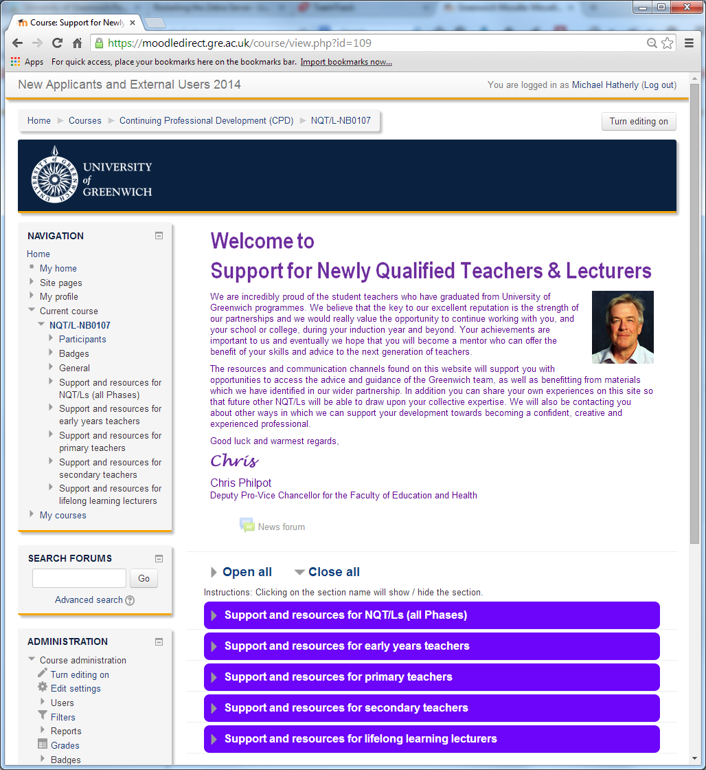
- You are able to select the URL link from the browser bar and copy this to be pasted into an email.

