MoodleDirect

User Guide for External Users

Each document should also be listed on our “Help Materials Log”, which can be found here - U:\ILS\LIS_Shared\Web Services\Help Materials.

VERSION | DATE | DETAILS | AUTHOR | AUTHORISED BY
M0.1 | 23/04/15 | Creation of document | Mike Hatherly

Contents
What is MoodleDirect? 2
Do I need to create an account ? 3
Creating an account 3
Log into MoodleDirect 6
Enrol on a course 8
Enrolling on a course from a URL link 8
Enrolling on a course by browsing 8
How to reset your password 10
If you created your own account (external users) 10
If you use a University of Greenwich Portal account to log in 11
Reset your password via the portal (previous setup of password security questions is required) 11
Reset your password via the University of Greenwich Information and Library Services Helpdesk 11

What is MoodleDirect?
MoodleDirect is the name of the site used by the University of Greenwich for external users.
The University of Greenwich also has a separate Moodle site for teaching of degree programmes, these two systems, whilst similar, should not be confused.

MoodleDirect contains courses for Continual Professional Development (CPD), Support for Graduates and Short Courses.

Do I need to create an account?
If you are not currently a member of staff at the University of Greenwich, and do not have a University of Greenwich Portal account, you will need to create an account (see Creating an account).

Creating an account
Before you are able to access MoodleDirect you will need to create an account.
- Open your browser and navigate to https://moodledirect.gre.ac.uk
- You will be presented with the authentication page as shown below.
Choose ‘Other users who do not have a portal account’
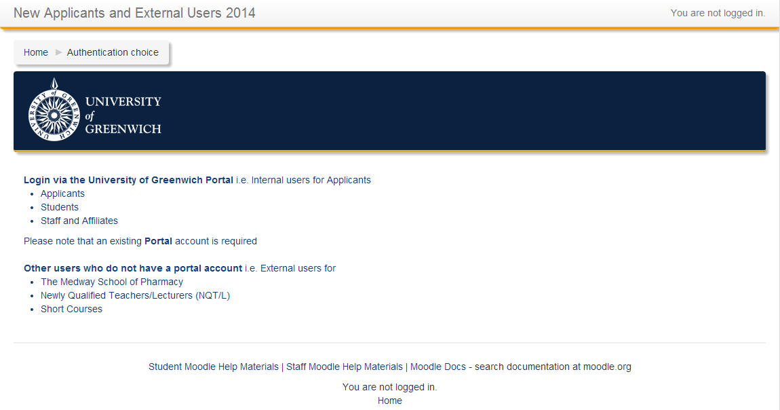
Select ‘Other users who do not have a portal account’.
- To create a new account click the ‘Create new account’ button
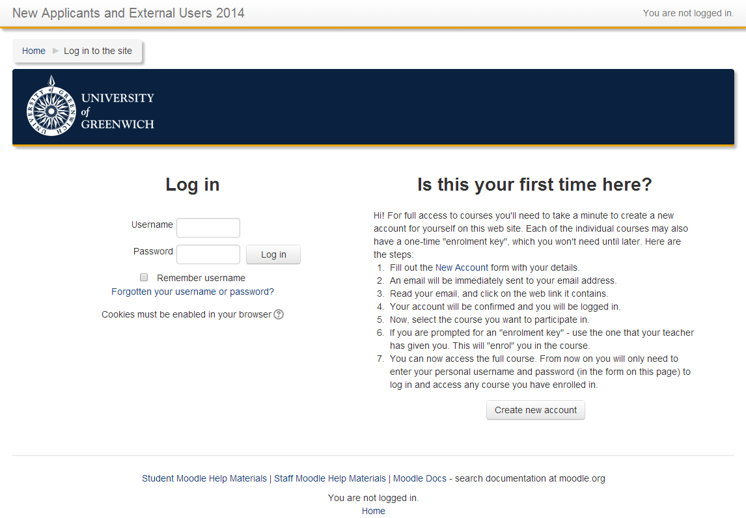
Click ‘Create new account’
- You will now be asked to choose a username and complete your details.
The username can only contain alphanumeric lowercase characters, underscore (_), hyphen (-), period (.) or at symbol (@)
For ease of remembering your username, we suggest that you use your email address
Fields marked with a * are compulsory
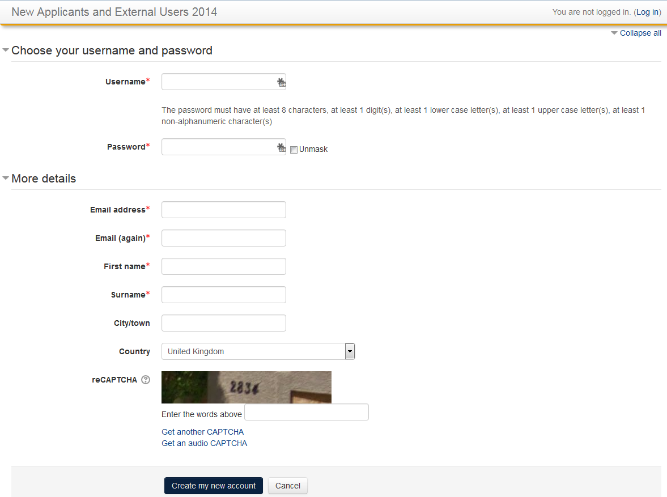
Click Create my new account when you have completed the form.
- Confirmation of account creation
Following completion of the form, confirmation of the account creation will be shown
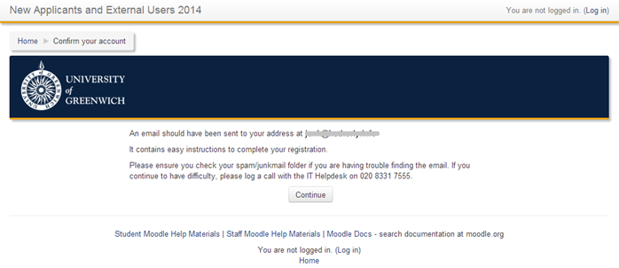
- To complete the sign-up process, please click the link in the email that has been sent to you.
If you are unable to find the email, please ensure you check your spam/junk folders in your email program.

Log into MoodleDirect
- Open your browser and navigate to https://moodledirect.gre.ac.uk
- You will be presented with the authentication page as shown below.
Choose ‘Other users who do not have a portal account’
Select ‘Other users who do not have a portal account’.
- Enter your username and password and then click Log in.
Enter your username and password and then click ‘Log in’

- Once logged in successfully, you will be shown the site home page
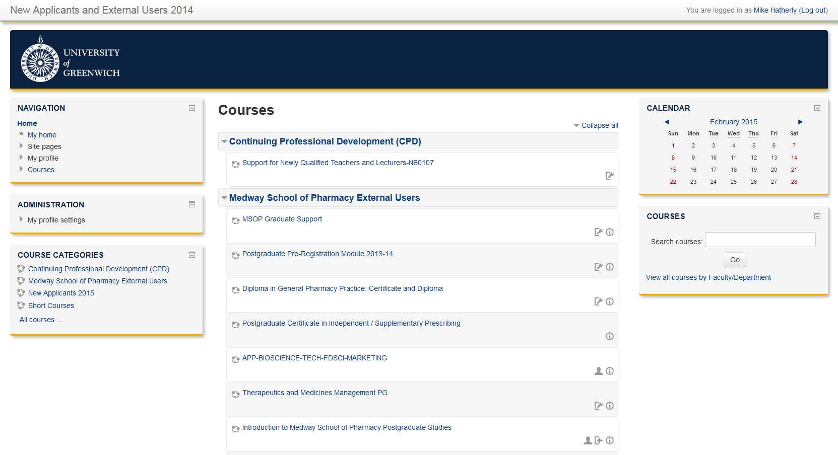
The course search box can be used to find a course if you can’t see it in the list. You can search for part of a word/course title
Courses are shown by category (in bold).
Collapse/Expand all will hide/show the courses in each category.
The Courses link in the Navigation block will also take you directly to a list of categories
Click the University of Greenwich Logo or Home in the Navigation block to return to this page
The Navigation block will show a link to ‘My Courses’ once you have enrolled on a course
Icons to the right of each course show the following:
This course requires an enrolment key (password)
Clicking this icon will give you more information about the course
This icon shows that the course can be viewed without enrolment (guest access)
This course has self-enrolment enabled (no password is required)
The Administration block allows you to change your settings, such as profile information and communication preferences

Enrol on a course
You can enrol on a course by clicking on a URL link that has been sent to you by the course leader, or by browsing to the course and choosing to enrol.

Enrolling on a course from a URL link
- Click on the link that has been provided to you.
If clicking on the provided link does not function, copy the link into the address bar of your internet browser.
- You will be prompted to log on, if you do not have an account you will need to create one before you proceed (see Creating an account)
- If the course requires an enrolment key (password), you will be prompted to enter it.
Enter the enrolment key (password) and then click the Enrol Me button
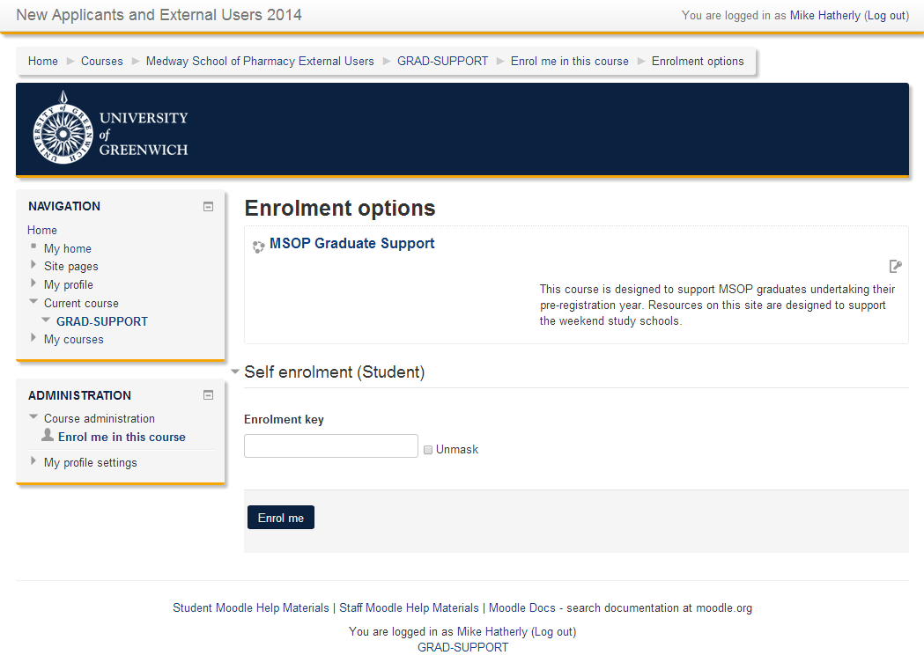
- If an enrolment key (password) is not required, and guest access is enabled, you will be able to view the course but not participate as you have not yet enrolled.
Click Enrol me in this course, which can be found in the Administration block on the left.

Enrolling on a course by browsing
- Log on to MoodleDirect (https://moodledirect.gre.ac.uk), if you do not have an account you will need to create one before you proceed (see Creating an account)
- Once logged on you will be presented with a list of categories and the courses in each category.
- Find the course you would like to enrol on
  - Search for the title of the course using the Course Search block on the left
  - Browse the courses by clicking on the category headings
- Click on the title of the course to enter the course
- If the course requires an enrolment key (password), you will be prompted to enter it.
Enter the enrolment key (password) and then click the Enrol Me button
- If an enrolment key (password) is not required, and guest access is enabled, you will be able to view the course but not participate as you have not yet enrolled.
Click Enrol me in this course, which can be found in the Administration block on the left.

How to reset your password

If you created your own account (external users)
- Open your browser and navigate to https://moodledirect.gre.ac.uk
- You will be presented with the authentication page as shown below.
Choose ‘Other users who do not have a portal account’
Select ‘Other users who do not have a portal account’.
- Click Forgotton your username or password
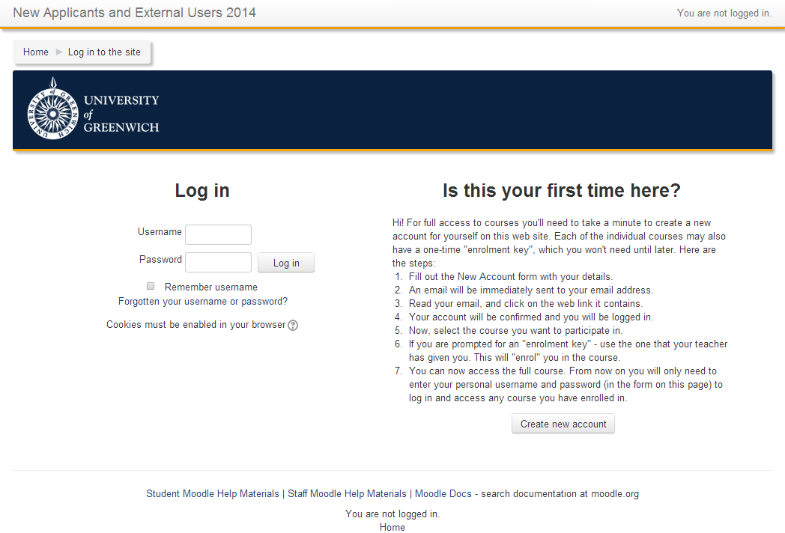
- You will be asked to enter your username OR email address used to register with the site.
Enter either of these and click Search
- If your username or email address has been found you will be sent an email with a link and instructions to reset your password. Please note that no error message will be produced if you have supplied details that are not found.
- If you have not received your password reset email, please check your spam/junk folder in your email program.

If you use a University of Greenwich Portal account to log in

Reset your password via the portal (previous setup of password security questions is required)
- Open your browser and navigate to http://portal.gre.ac.uk
- Click on the Lost Password button

Reset your password via the University of Greenwich Information and Library Services Helpdesk
Please send an email to helpdesk@gre.ac.uk asking for your password to be reset, don’t forget to include your user id.

